Case Study Practical
Helpdesk Troubleshooting Practical Assignment
1. Laptop won't power on even when plugged in
Aim
To identify why a laptop does not turn on even when its charger is connected, using basic troubleshooting steps.
Five troubleshooting steps
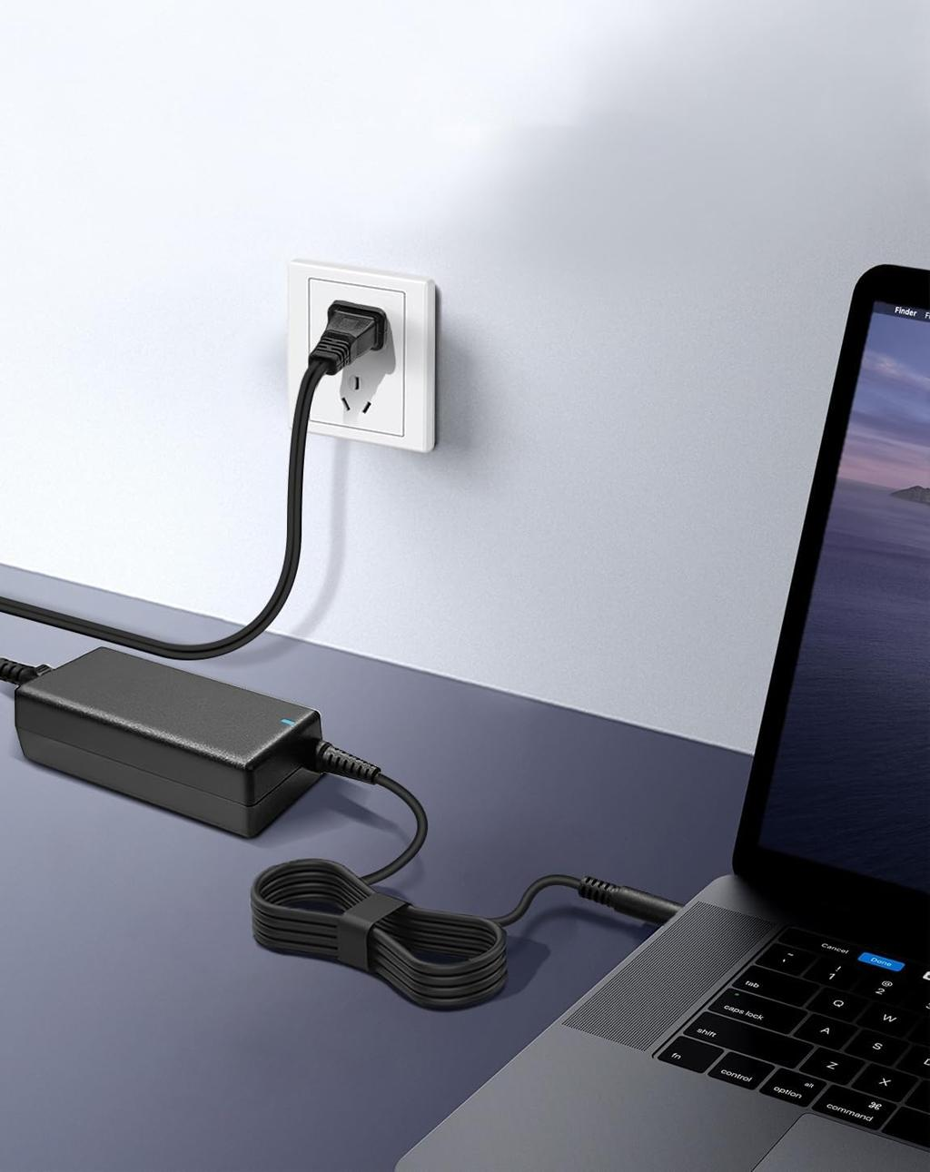
Step 1: Check the power outlet
- Ensure the wall socket is switched on.
- Test the outlet with a known-working device.
- Check any extension board or surge protector.
What am I checking? Whether electrical power is reaching the laptop charger.
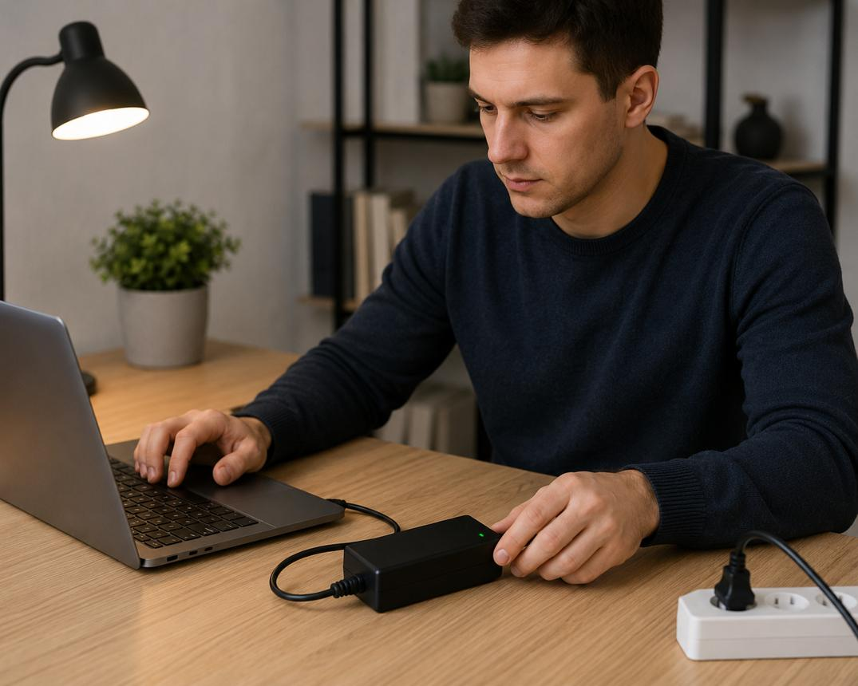
Step 2: Inspect the charger and cable
- Check for cuts, bent connectors, exposed wires, or burn marks.
- Ensure the charger is compatible with the laptop.
- If available, test with a known-working compatible charger.
What am I checking? Whether the charger or cable is damaged or failing to deliver power.
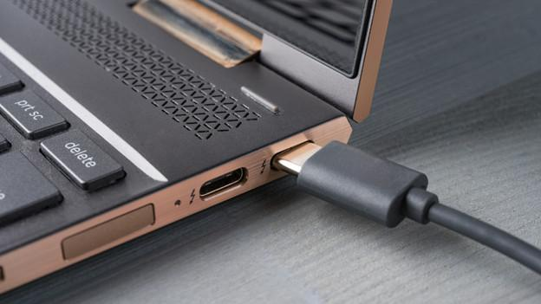
Step 3: Inspect the charging port and indicator
- Look for a loose or damaged charging port.
- Connect the charger and check whether the charging LED turns on.
- Check whether the connector fits securely without forcing it.
What am I checking? Whether power appears to reach the laptop and whether the charging connection may be faulty.
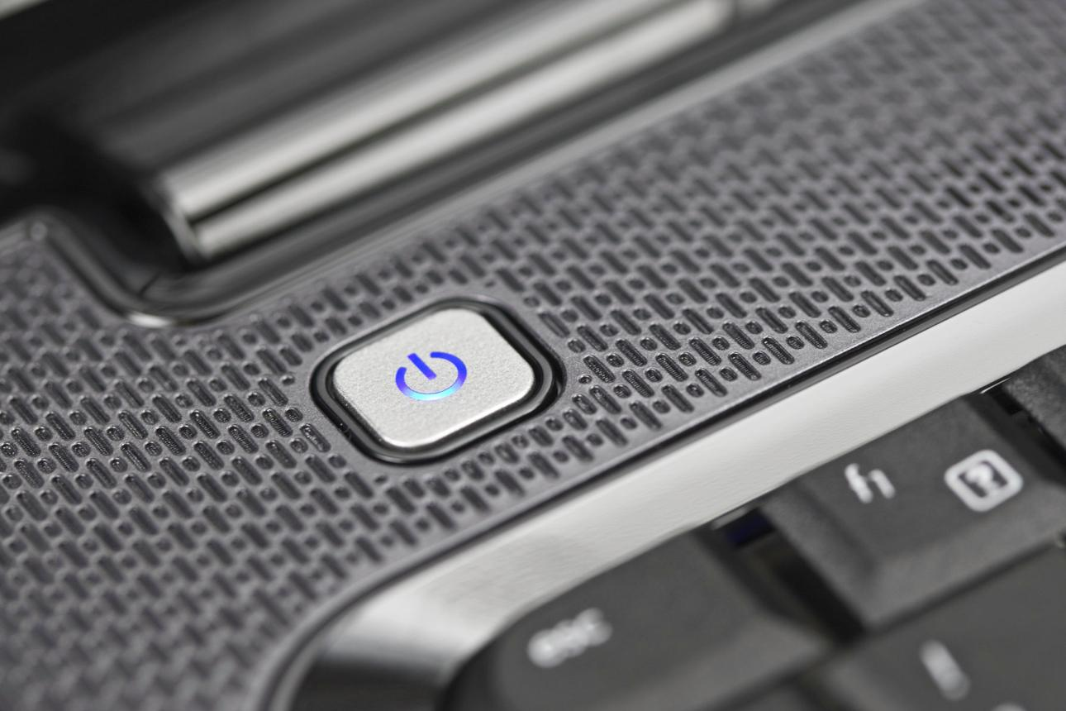
Step 4: Perform a safe power reset
- Disconnect the charger and external accessories.
- If the manufacturer permits it, remove the removable battery.
- Hold the power button for 15–20 seconds.
- Reconnect the charger and try to turn on the laptop.
What am I checking? Whether a temporary power-controller state is preventing startup.
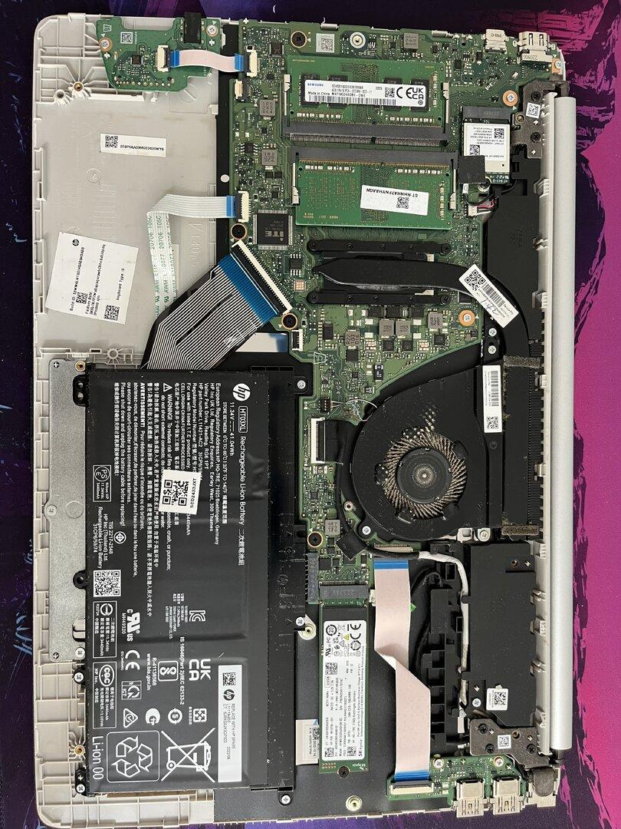
Step 5: Investigate internal hardware
- If the laptop remains unresponsive, arrange qualified inspection of the battery, DC jack, power circuitry, RAM, and motherboard.
- Note any diagnostic LEDs, fan movement, or beep codes.
What am I checking? Whether an internal component or power circuit is preventing the laptop from starting.
Troubleshooting results table
Observation | Possible cause
No charging light and no power | Charger, outlet, port, or internal power fault
Charging light works, but laptop does not start | Power button, battery, motherboard, or other internal fault
Laptop starts with another compatible charger | Original charger or cable may be faulty
Laptop starts after a power reset | Temporary controller state may have caused the issue
Conclusion: Start with the outlet, charger, and charging port before investigating internal hardware. Never open a charger or handle internal laptop components while the device is connected to power.
2. Helpdesk ticket: Monitor shows a blank screen, but the PC seems to be running
Aim
To identify whether the blank screen is caused by the monitor, display cable, graphics card, memory, or display settings.
Step-by-step troubleshooting flow
Start: Monitor is blank
PC appears to be running.
Step 1: Check monitor power
Power LED on? Correct input selected?
Step 2: Check display cable
Reseat HDMI/DisplayPort and try a known-working cable.
Step 3: Test another display
Try a known-working monitor or compatible display.
Step 4: Check the PC's startup
Look for POST errors, beep codes, and diagnostic LEDs.
Step 5: Check graphics hardware
Verify the GPU connection and required power cables with power disconnected.
Step 6: Check display settings or drivers
If an image appears, verify display mode, resolution, and graphics drivers.
Detailed troubleshooting procedure
- Check monitor power. Ensure the power cable is secure and the monitor's power indicator is on. Open its on-screen menu. If the menu appears, the monitor has power and can display its own menu.
- Check the input source. Select the input that matches the connected cable, such as HDMI 1, HDMI 2, or DisplayPort.
- Check the display cable. Reseat both ends of the cable. Test another compatible cable and port. A loose or faulty cable may cause a “No Signal” message.
- Test with another monitor. Connect the PC to a known-working monitor or compatible TV. If the second display works, investigate the original monitor or its cable.
- Check the PC's POST status. Observe startup diagnostic LEDs and beep codes. If the system fails POST, the problem may involve RAM, the GPU, the motherboard, or power delivery.
- Check the GPU connection. If the PC has a dedicated graphics card, ensure the display cable is connected to the correct GPU output. With the PC powered off and unplugged, a technician can inspect GPU seating and its power connectors.
- Check display settings. If the picture appears intermittently or on another display, verify the selected display mode, resolution, refresh rate, and graphics driver. On Windows, Win + P opens the projection options, although this shortcut will not fix a PC that has not completed POST.
- Confirm the fix. Restart the PC and check that the display works through startup and normal use.
Troubleshooting decision table
Finding | Likely area to investigate
Monitor's own menu does not appear | Monitor power or monitor hardware
Monitor shows “No Signal” | Cable, input selection, GPU output, or PC startup
Another monitor works | Original monitor, cable, or display compatibility
PC gives a memory-related POST error | RAM or memory subsystem
BIOS appears, but the screen goes blank when Windows loads | Graphics driver, resolution, or operating-system configuration
Conclusion: Check the monitor, input source, and cables first. If these are working, investigate POST errors and graphics hardware. Check Windows display settings and drivers only when the PC has progressed far enough to load the operating system.
3. Wireless mouse is unresponsive, but the keyboard works
Aim
To determine whether the fault is with the wireless mouse, USB port, wireless receiver, battery, or system settings.
Step-by-step troubleshooting procedure
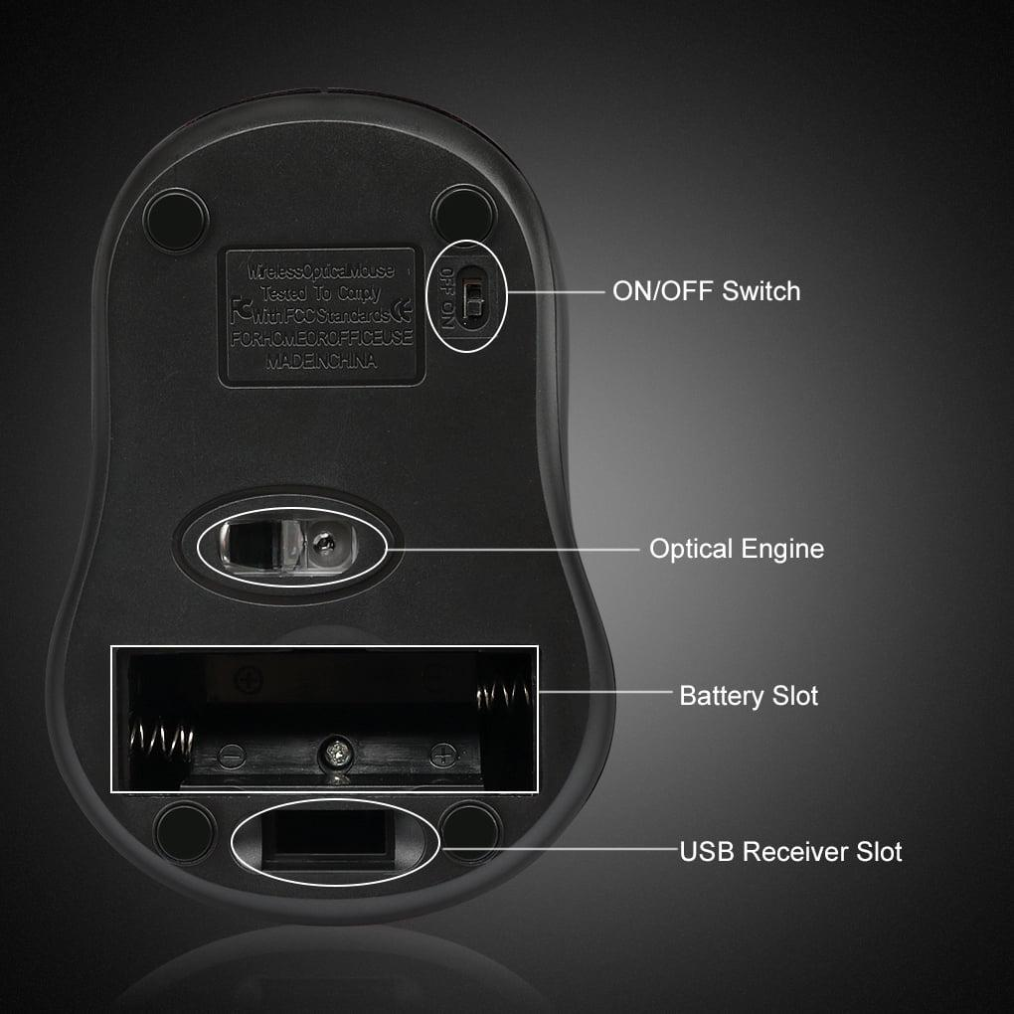
Step 1: Check the mouse power and battery
- Switch the mouse off and on.
- Replace the battery or recharge it.
- Check whether the optical sensor light or indicator behaves normally, if the model has one.
What this checks: Whether the mouse has power.
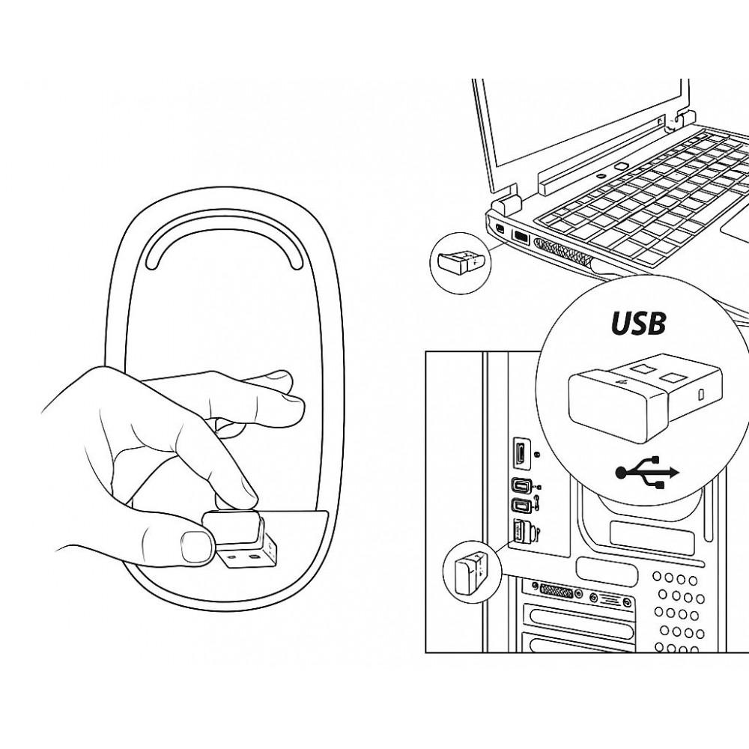
Step 2: Check the USB receiver
- For a 2.4 GHz wireless mouse, ensure its USB receiver is connected securely.
- Try a different USB port, preferably a direct port on the computer rather than a hub.
- For Bluetooth mice, confirm Bluetooth is enabled and the mouse is paired.
What this checks: Whether the wireless connection or receiver is working.
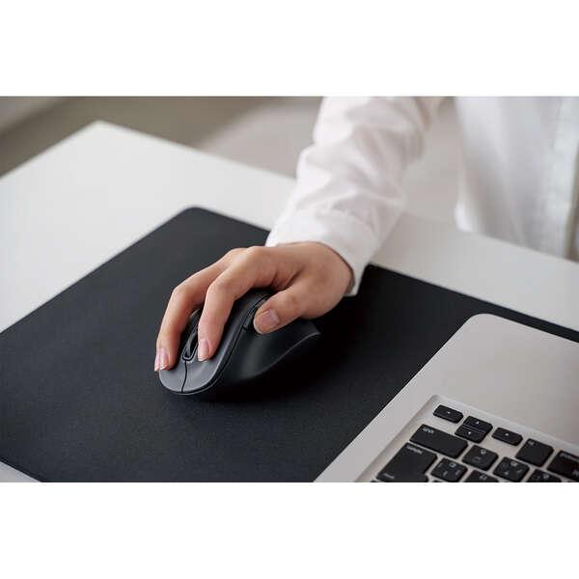
Step 3: Test the mouse on another computer
- Connect its receiver to another compatible computer or pair it through Bluetooth.
- Test cursor movement and clicking.
What this checks: If it fails on another computer too, the mouse, battery, or receiver may be faulty.
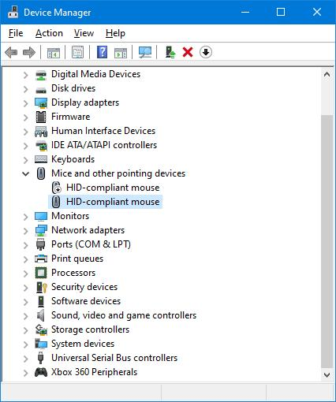
Step 4: Check system settings
- Use the working keyboard to navigate Windows Settings.
- Check Bluetooth settings if the mouse uses Bluetooth.
- Open Device Manager and look under Mice and other pointing devices, Human Interface Devices, and Universal Serial Bus controllers for warnings.
What this checks: Whether Windows detects the mouse or reports a driver or device problem.
Step 5: Isolate the USB port or system
- Test another USB device in the original port.
- Test the mouse receiver in another known-working port.
- Restart the computer and reconnect or re-pair the mouse if necessary.
What this checks: Whether the issue follows the mouse, stays with one USB port, or is related to Windows configuration.
How to identify the cause
Test result | Likely cause | Next action
Mouse works after replacing the battery | Weak or depleted battery | Replace or recharge the battery
Mouse fails on two computers | Mouse or receiver fault | Check pairing and receiver; replace faulty hardware if confirmed
Mouse works in another USB port | Original USB port or connection issue | Inspect the original port and its configuration
Other USB devices also fail in the same port | USB port, controller, or driver issue | Test another port and inspect Device Manager
Mouse works on another computer but not this PC | System settings, driver, pairing, or USB configuration | Check Bluetooth, Device Manager, and system updates
Conclusion: Start by checking the mouse battery and receiver, then test another USB port and another computer. These comparisons help isolate the fault without unnecessarily replacing working hardware.
4. Gaming café PC overheats and shuts down during use
Aim
To identify three possible hardware causes of overheating and unexpected shutdowns in a gaming PC, and describe how to check each one.
Three possible hardware causes
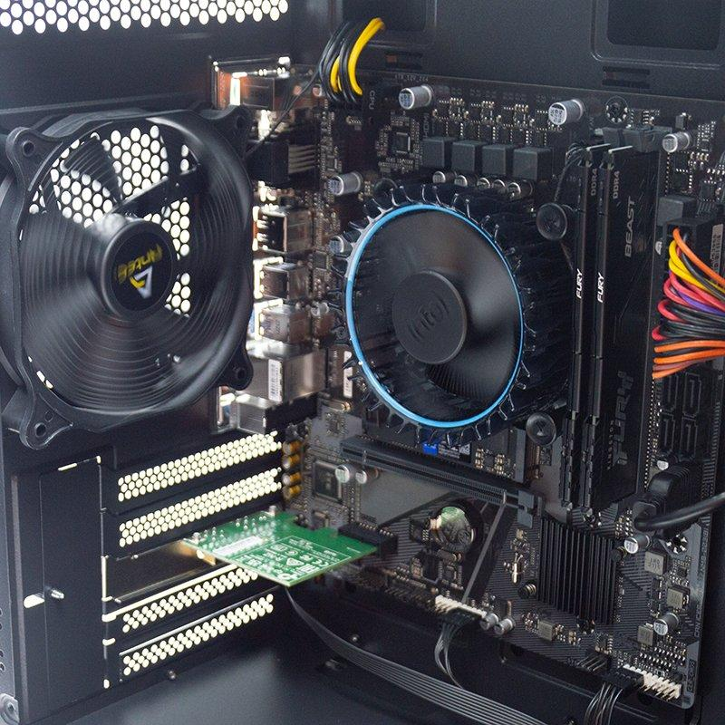
Cause 1: Faulty or blocked cooling fans
Why it causes overheating: If the CPU cooler fan or case fans fail, hot air may accumulate inside the case and the CPU or GPU may become too hot.
How to check:
- Inspect the fans while the system is operating, without touching them.
- Check for unusual noise, obstruction, or a fan that does not rotate when cooling is needed.
- Power off and unplug the PC before removing obstructions or checking fan connectors.
- Replace a faulty fan with a compatible model.
Possible solution: Restore proper fan operation and airflow.
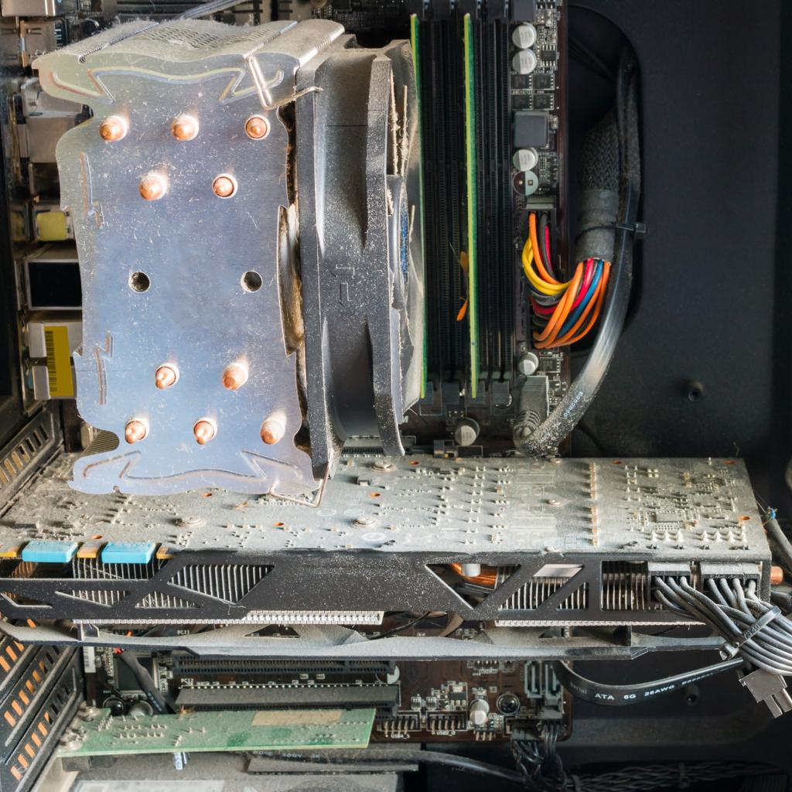
Cause 2: Dust buildup in heatsinks and air vents
Why it causes overheating: Dust restricts airflow and reduces heat transfer through the heatsinks and cooling fins.
How to check:
- Shut down and unplug the computer.
- Inspect the CPU cooler, GPU heatsink, filters, and case vents.
- Check for dust mats blocking airflow.
- Clean with appropriate compressed air or an electronics-safe method, following manufacturer guidance and preventing fans from overspinning.
Possible solution: Clean the filters, fans, heatsinks, and vents to restore airflow.
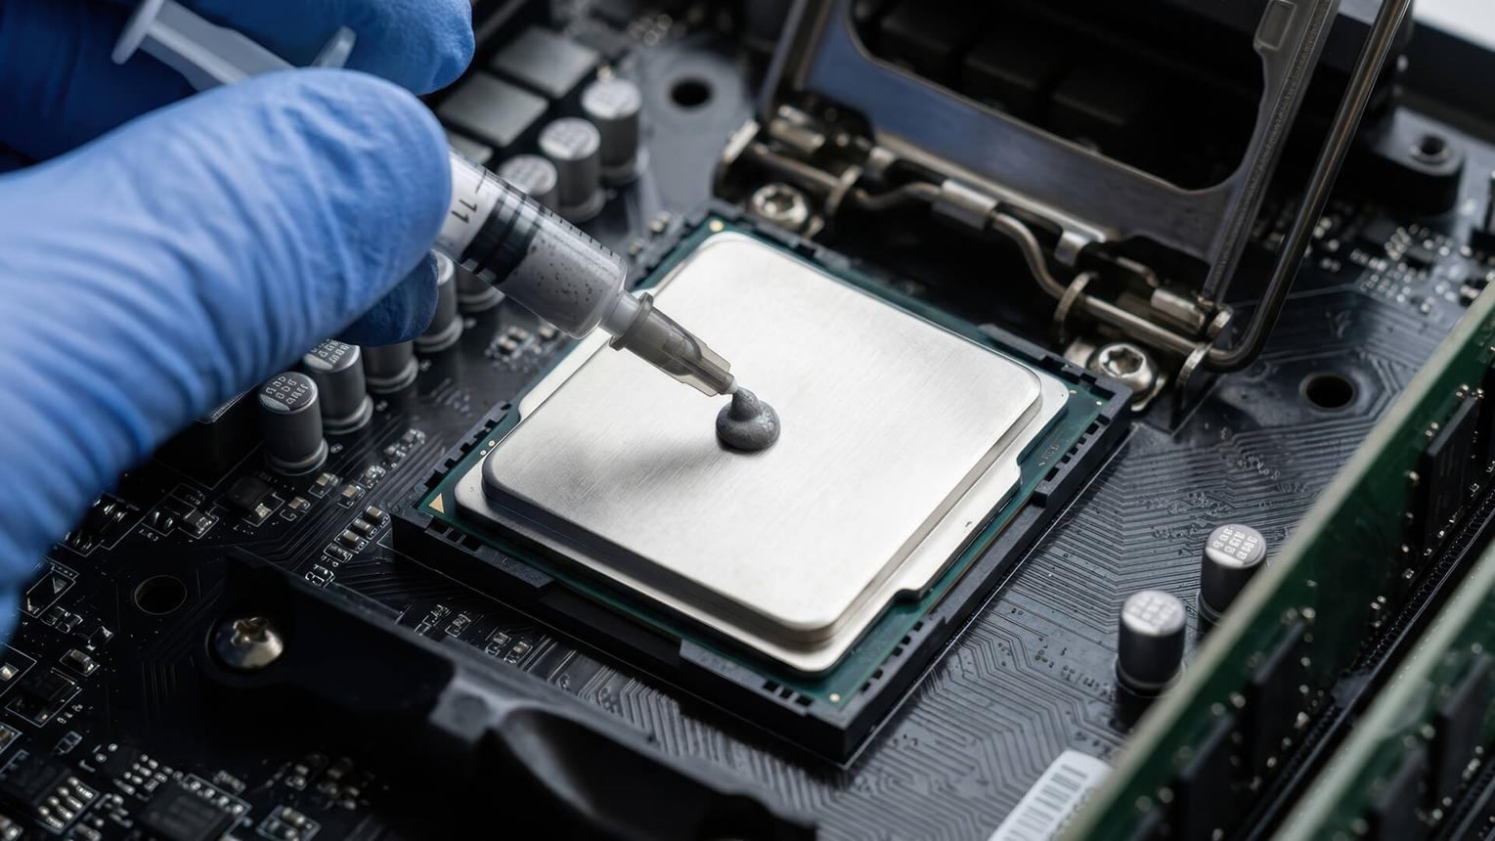
Cause 3: Dried thermal paste or poor heatsink contact
Why it causes overheating: Thermal paste helps transfer heat from the CPU to its cooler. Dried or poorly applied paste, or an incorrectly mounted heatsink, can reduce heat transfer.
How to check:
- Observe whether the CPU temperature rises unusually quickly under load, using suitable monitoring software.
- Check for a loose cooler or incorrect mounting.
- If necessary, have a qualified technician remove the cooler, clean the old paste with suitable materials, apply the recommended amount of new paste, and reinstall the cooler correctly.
Possible solution: Restore proper heatsink contact and thermal transfer.
Troubleshooting and verification checklist
Step | Action | Expected result
1 | Record when the shutdown occurs | Determine whether it happens during gaming, idle, or startup
2 | Check CPU and GPU temperatures using appropriate monitoring software | Identify possible excessive temperatures
3 | Inspect fans and airflow | Confirm fans operate properly and vents are not blocked
4 | Inspect the CPU cooler and mounting | Confirm that the heatsink is secure
5 | Clean dust and repair identified cooling faults | Improve airflow and heat transfer
6 | Test the PC under normal gaming conditions | Confirm that temperatures remain appropriate and shutdowns do not recur
Conclusion: Faulty fans, dust buildup, and poor thermal-paste or heatsink contact are three common hardware causes of overheating. Inspect the cooling system, correct the identified fault, and retest the gaming PC. If overheating continues, investigate GPU cooling, the PSU, case airflow, and other possible causes.
Safety note: If a gaming PC repeatedly shuts down due to overheating, stop stress-testing it until the cause has been investigated.

